**Practical No 8**

**Aim: Study of Component Diagram**

Component diagrams are different in terms of nature and behaviour. Component diagrams are used to model the physical aspects of a system. Now the question is, what are these physical aspects? Physical aspects are the elements such as executables, libraries, files, documents, etc. which reside in a node. Component diagrams are used to visualize the organization and relationships among components in a system. These diagrams are also used to make executable systems.

**Notation For Component Diagram:**

* **Association**: An association specifies a semantic relationship that can occur between typed instances.
* **Composition:** Composite aggregation is a strong form of aggregation that requires a part instance be included in at most one composite at a time. If a composite is deleted, all of its parts are normally deleted with it.
* **Aggregation:** A kind of association that has one of its ends marked shared as kind of aggregation, meaning that it has a shared aggregation.
* **Constraint:** A condition or restriction expressed in natural language text or in a machine-readable language for the purpose of declaring some of the semantics of an element.
* **Dependency:** A dependency is a relationship that signifies that a single or a set of model elements requires other model elements for their specification or implementation.
* **Links:** A generalization is a taxonomic relationship between a more general classifier and a more specific classifier. Each instance of the specific classifier is also an indirect instance of the general classifier. Thus, the specific classifier inherits the features of the more general classifier.

**When to Use**

We have already described that component diagrams are used to visualize the static implementation view of a system. Component diagrams are special type of UML diagrams used for different purposes. These diagrams show the physical components of a system. To clarify it, we can say that component diagrams describe the organization of the components in a system. Organization can be further described as the location of the components in a system. These components are organized in a special way to meet the system requirements. Component diagrams are very important from implementation perspective.

Component diagrams can be used to:

* Model the components of a system.
* Model the database schema.
* Model the executables of an application.
* Model the system's source code.

**A. You are appointed as consultant for intranet development of your college web site. Draw component diagram.**

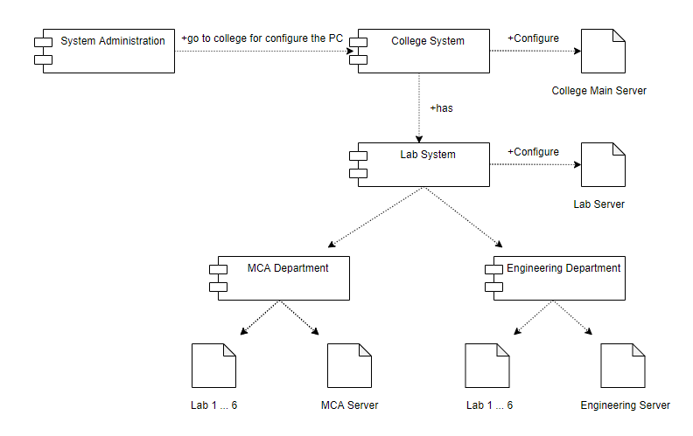

**Conclusion: We have studied the details about the component diagram.**